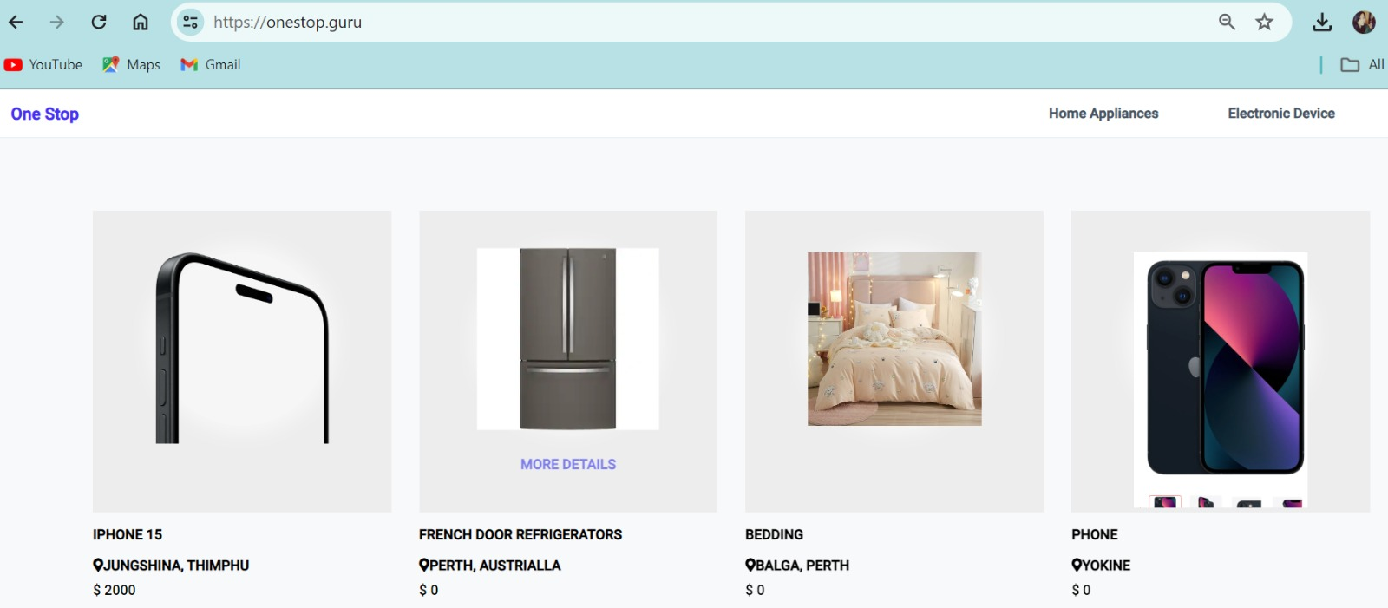

Name: Pelden Lhamo

Student ID: 34778367

Year: 2024

Tutor: [Subash khati](mailto:subash.khati@murdoch.edu.au)

Unit name: [ICT171 Introduction to Server Environments and Architectures (s1, 2024)](https://moodleprod.murdoch.edu.au/course/view.php?id=24566#section-16)

Public IP address: 3.27.43.30  
Domain name: https://onestop.guru/

**Table of content**

|  |  |  |
| --- | --- | --- |
| No | Topics | Page No |
| 1 | How to create instance | 3-10 |
| 2 | How to Install Django with Apache on Ubuntu server? | 10-11 |
| 3 | Install MySQL and create a database | 12-13 |
| 4 | Creating your Django project | 15-17 |
| 5 | Configure Apache Web Server for Django | 17-18 |
| 6 | Checking logs | 18-19 |
| 7 | Some of the issue face and solution | 19-20 |
| 8 | Best practice for project structure | 21-22 |
| 9 | Database backup using Script and Cron job | 22-24 |
| 10 | Setting up the Go Daddy Domain Name with server | 24-28 |
| 11 | Enable port 443 using Cerbot | 28-31 |
| 12 | Auto Renew the Certificates | 32 |
| 13 | Some of the Linux commands used | 32-33 |
| 14 | Scripts | 33-36 |
| 15 | References | 36 |

**Objective of the project (onestop)**

Another successful implementation on amazon’s EC2 is the “One Step” project, this makes a site transnational available at the IP 3. 106. 165. 87, helping immigrants by providing them with cheap second-hand goods, promoting community support, sustainability, and its incorporation of seller partnerships with second-hand retail outlets.

This document consists of detailed guideline to deploy a Django site on an Amazon EC2 to achieve the objective of the project. It starts with creating instance in amazon cloud platform.

**Easy and quick process to create EC2 instance.**

Amazon EC2 is considered as the most reliable cloud computing architecture which enables to both create and operate the virtual server(instances) by allowing to run various kind of applications and workloads.

Instance means the host that is a server which utilizes cloud whereby an application can be run on it. Most of the workplaces continue to rely within high-cost ways of operating especially the physical servers, hence the inefficiency. The hardware on the other hand is confined to cloud providers while the application is with users, which we can login remotely. Various application such as containers, databases, microservices and virtual machines can be run on instance.

**Initial setup starts with two basic things:**

1. An active Amazon Web Services (AWS) account required for creating EC2 instances.
2. AWS Console Access: Access to the AWS Management Console.

**Detail steps process is:**

**Step I: First the user had to sign in to the AWS Management Console**

1. Open the browser and go to the AWS Management Console.
2. Log in using your AWS account credentials.



**Step II: Go to the EC2 Dashboard**

1. Once logged in, type "EC2" in the “Find Services” search bar and select it. This will bring you to the EC2 Dashboard.

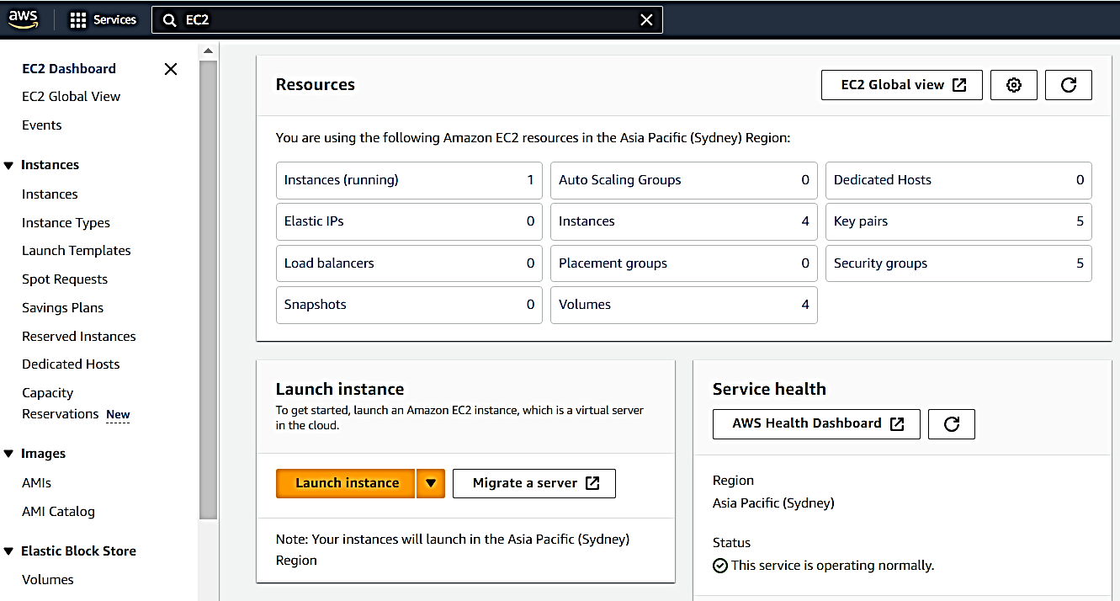

**Step III: Start Instance Launch**

1. Click the “Launch Instance” button on the EC2 Dashboard to begin creating a new instance.

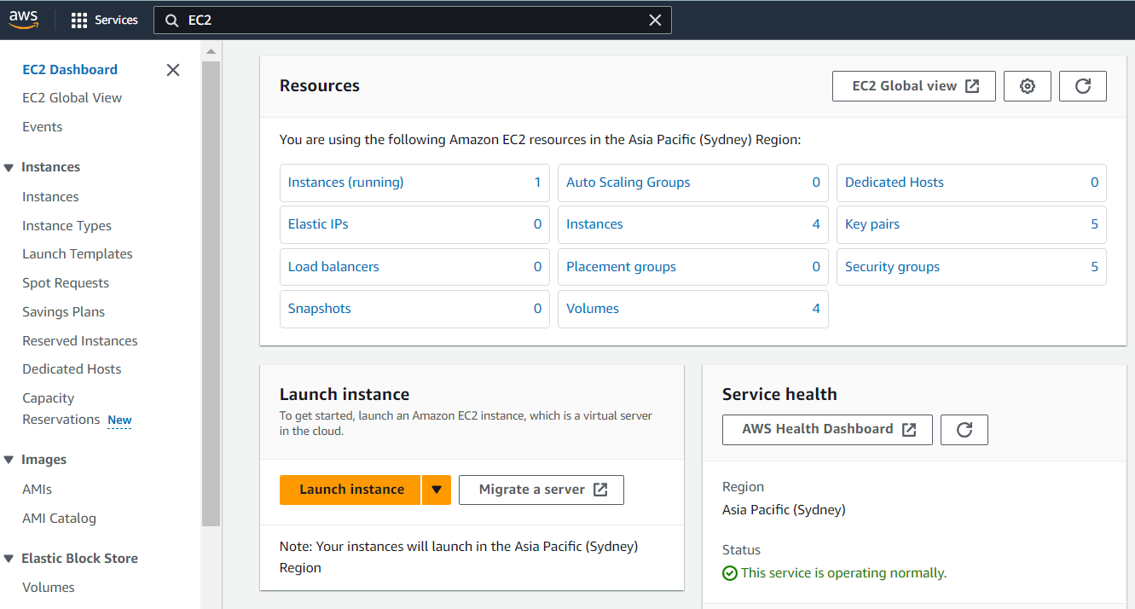

**Step IV: Name Your Instance**

1. Enter a name for your new instance.

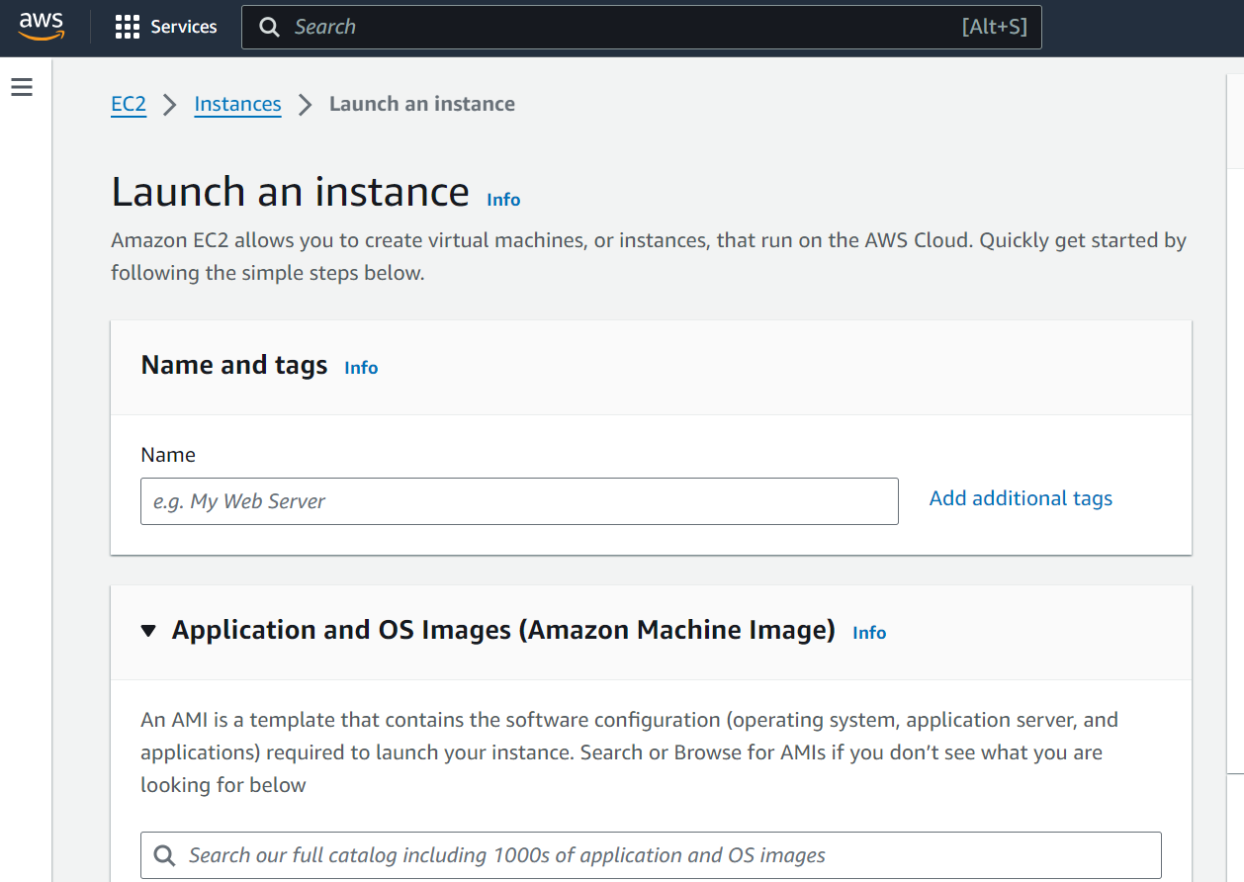

**Step V: Select an Amazon Machine Image (AMI)**

An AMI is a template that contains the software configuration (operating system, application server, and applications) required to launch your instance.

1. Choose an AMI that fits your needs, such as Amazon Linux, Ubuntu, or Windows Server.

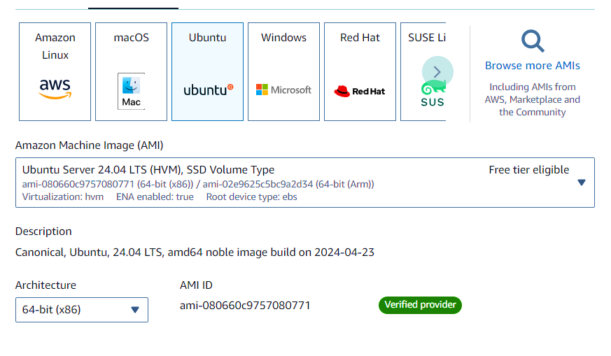

**Step VI: Select an Instance Type**

1. The instance type determines the hardware specifications for your instance.
2. You can choose an instance type based on the computational power, memory, and storage needs of your application.

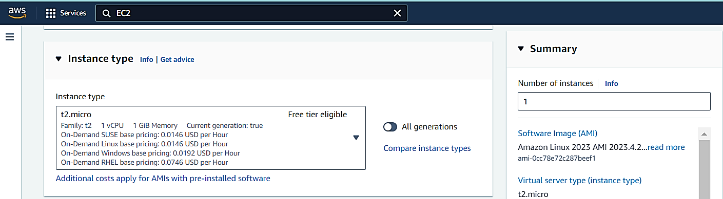

**Step VII: Configure Instance Details**

1. Specify the number of instances you want to launch.

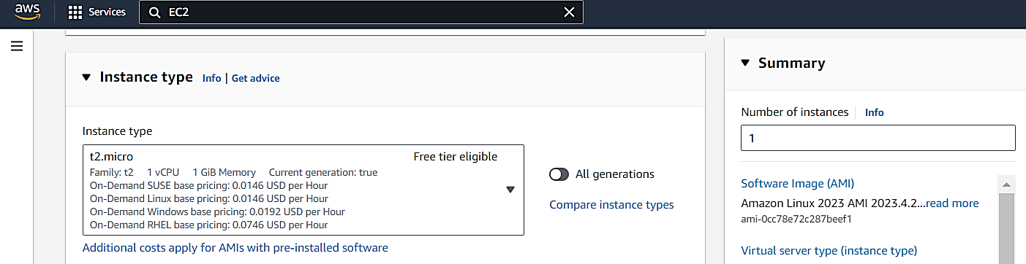

**Step VIII: Set Up Network Settings**

1. In the "Network Settings" section, select a VPC (Virtual Private Cloud) and subnet for your instance.
2. You can configure a security group, which acts as a firewall to control traffic to and from your instance. Set rules for SSH, HTTP, HTTPS, and any other necessary protocols.

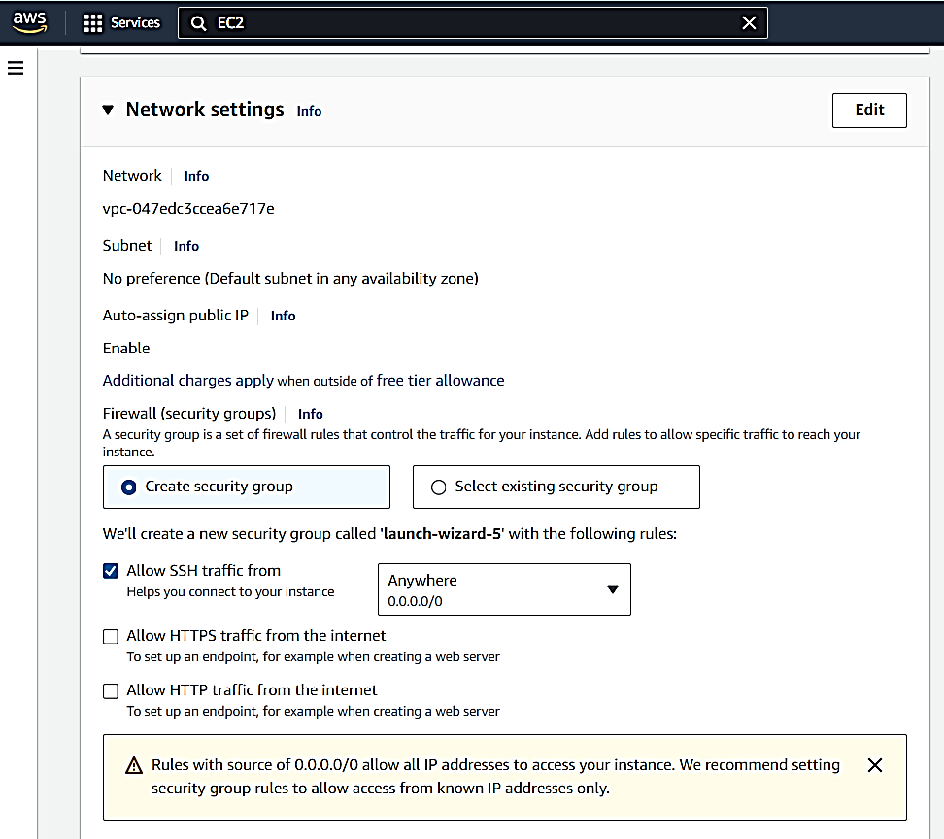

**Step IX: Create a Key Pair**

1. Key pairs are essential for secure SSH access to your instance.
2. You can choose to create a new key pair, name it, and download the private key file (.pem). Keep this file secure, as it is needed for accessing your instance.

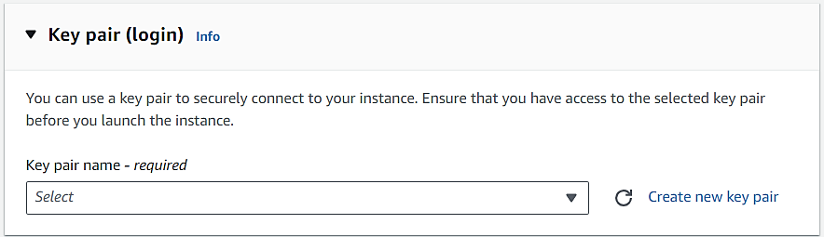

**Step I: Review and Launch Your Instance**

1. You can review all your configurations.
2. If everything you have followed all the correct steps, click the “Launch” button to start your instance instantly.

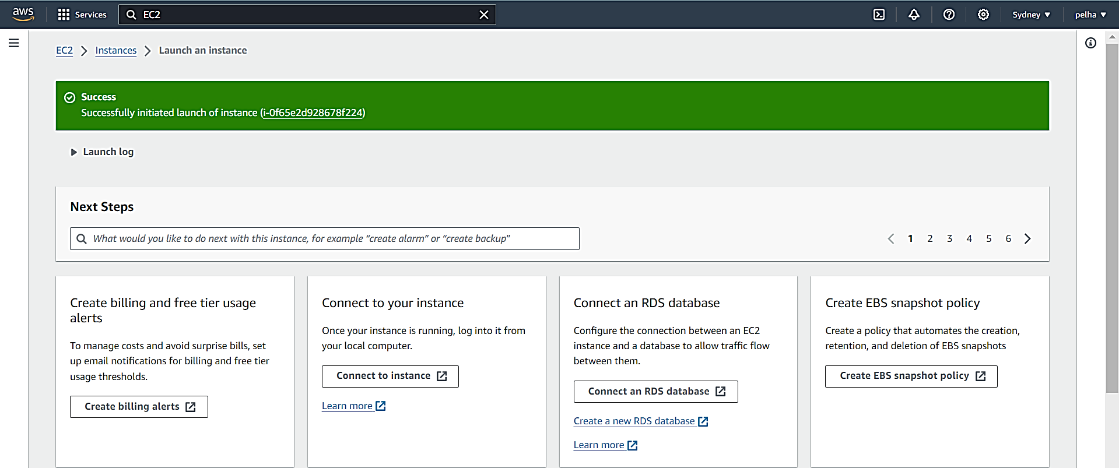

**Step II: Connect to Your Instance**

1. After your instance is running, find its public IP address in the EC2 Dashboard under “Instances.”
2. Use the private key file to connect to your instance via SSH (for Linux/Unix) or Remote Desktop (for Windows).

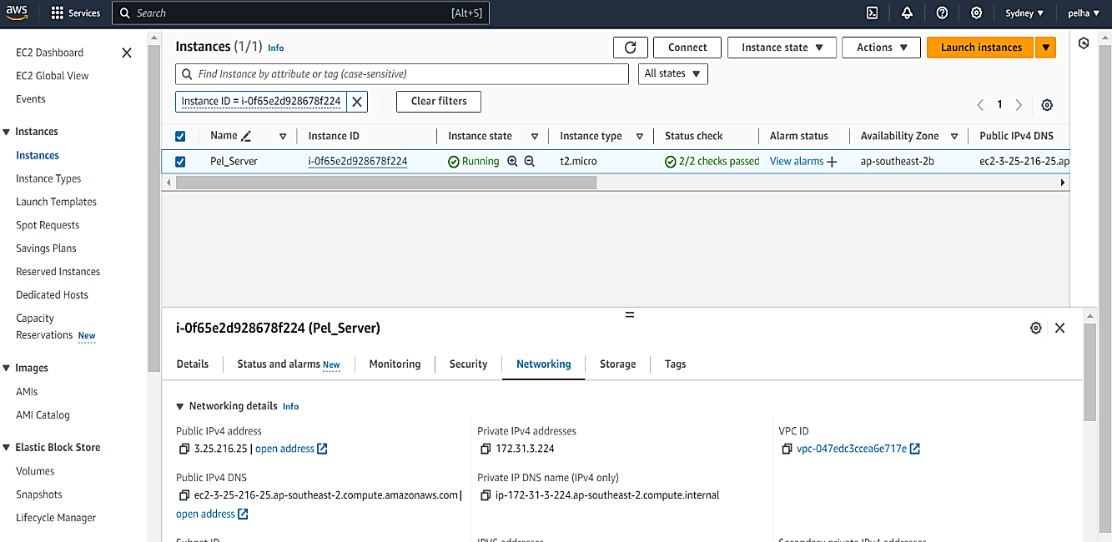

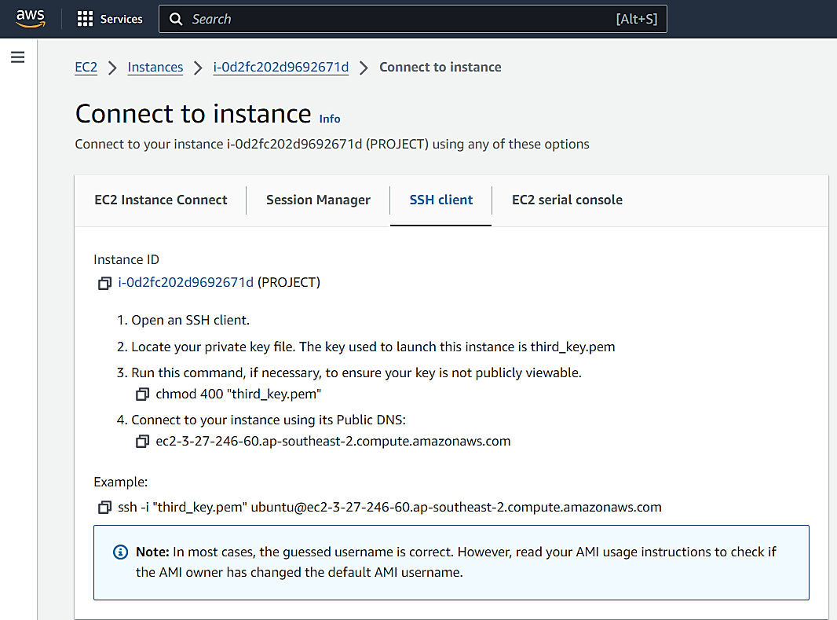

**Why Django for web application**

Django is an open-source web application development framework for Python which gives the developers an effective way to design web applications. This has many pre-installed functionalities such as registration of users, managing of database, and an admin page to manage the website thus reducing the time and energy used. Django is secure, scalable, and has a massive support community, which is why it is suitable for any project.

**How to Install Django with Apache on Ubuntu server?**

**Step 1**: sudo apt update && sudo apt upgrade –y

This command updates the system to the latest version of the intended software.

**Step 2**: sudo apt install apache2 libapache2-mod-wsgi-py3

These commands install the wsgi (web server gateway interface). This wsgi helps to allow apache2 to work with python3.

**Step 3:** systemctl start apache2

This command is instructing the system to start the Apache web server service, making it actively listen for incoming web requests and serving content.

**Step 4**: systemctl enable apache2

You are telling the system to configure Apache to start automatically during the system boot process.

**Step 5**: systemctl status apache2

The command displays the current status of apache2 service stating whether the service is running or not.

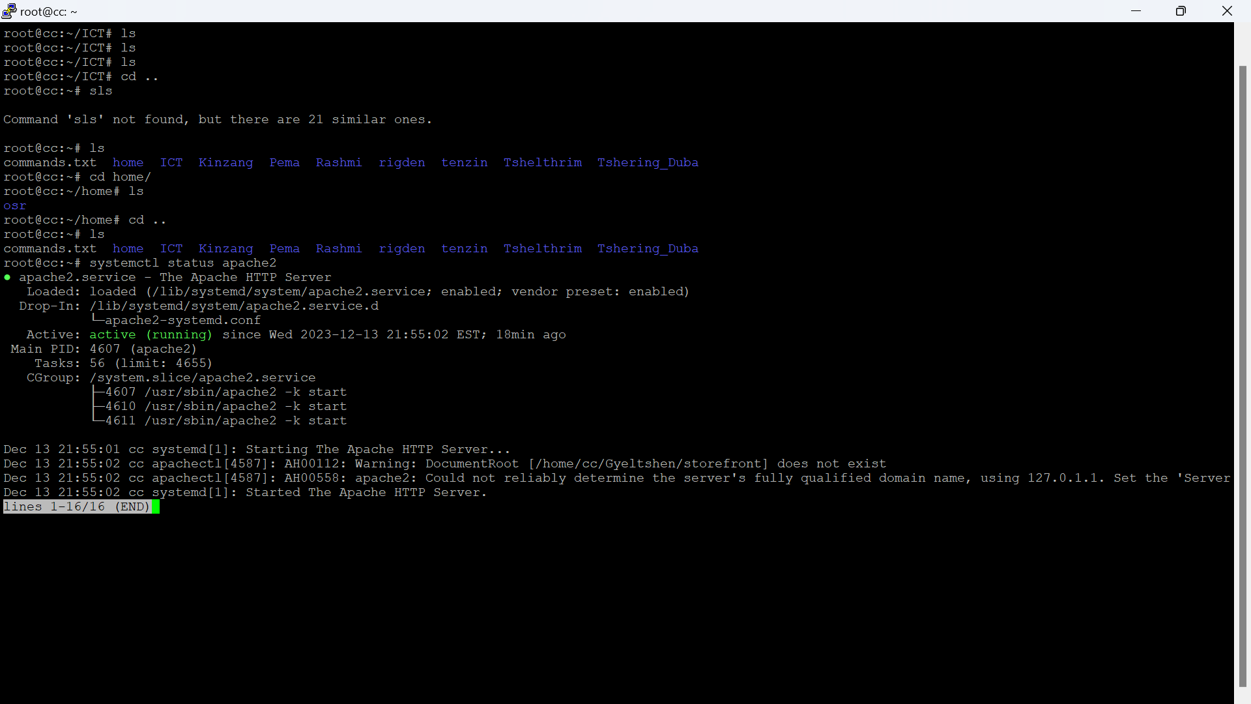

## **MySQL**

MySQL is fundamental because it is one of the most popular, stable, and effective DBMS. It is the database that manages the data of websites and applications to enable easy access and manipulation of the data. MySQL is one of the most widely used, general-purpose, open-source relational database management systems due to its simplicity, scalability, and affordability to businesses.

## **Install MySQL and create a database.**

**Step 1:** sudo apt install mysql-server libmysqlclient-dev

**libmysqlclient-dev**: This is another package you are installing. It contains development files and libraries that are necessary for compiling and linking programs with the MySQL client library.

**Step 2:** systemctl start mysql

The command systemctl start mysql initiates and starts MySQL database service on a system using systemd.

**Step 3:** systemctl enable mysql

The command will enable to configure the MySQL service to start automatically on boot.

**Step 4:** systemctl status mysql

It displays your current status of the MySQL service whether the service is running, stopped, or crashed, as well as recent log entries.

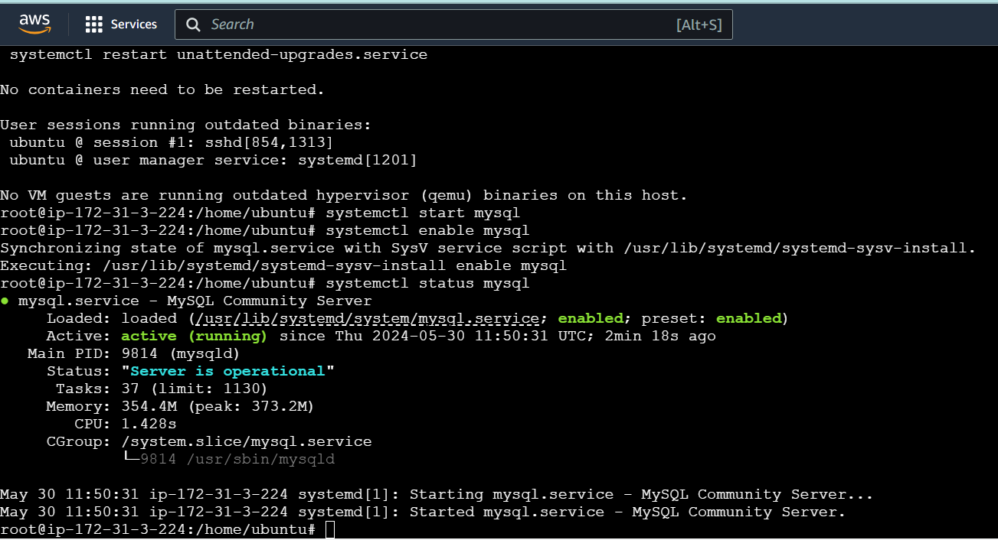

**Step 5:** mysql -u root

mysql> CREATE DATABASE django_db;

Creates database named django_bd.

mysql> CREATE USER *'django_user'*@'localhost' IDENTIFIED BY *'Pa$$word'*;

Creates users as django_user by assigning password as Pas$$word.

mysql> GRANT ALL ON *django_db*.* TO *'django_user'*@'localhost';

Grants permission for accessibility to username django_user.

mysql> FLUSH PRIVILEGES;

Using this command helps to make changes instantly as per changes made to user privileges without having to reboot the system.

mysql> EXIT

Leave mysql mode.

**Note:** Italic words should be replaced by yourself.

## **Install Pip on Ubuntu 22.04**

Pip is an abbreviation of “Pip Installs Packages” and pip is the standard package manager for Python. It enables the users to add other libraries and packages, which are not existing in the python standard library.

**Step 1:** sudo apt install python3-venv python3-pip (pip3 –version)

Installs python version 3.

## **Install Django Using Virtual Environment**

It is advisable to install Django in a virtual environment because it helps in managing the dependencies of a project separately from those in the system. This way, different projects can be installed Django and other libraries, each with a version unique to its project, thus there will not be overlapping. It also defines and manages dependencies in a better way and your system remains neat.

**Step 1:** Create a project directory using mkdir *foldername*.

You can create your project directory anywhere you want to create with your desired directory name.

**Step 2:** **python3 -m venv *envfoldername.***

Create your env inside your project directory using this command.

**Step 3:** **source *envfoldername*/bin/activate.**

Activate your virtual environment by using this command

**Step 4:** **pip install django** (django-admin –version)

Installs Django

**Step 5:** pip install MySQLclient (Optional)

## **Creating your Django project**

Note: Italic words should be replaced by yourself.

**Step 1:** django-admin startproject *django_app*.

Dot indicates the project is being created in same directory.

**Step 2**: nano django_app/settings.py

This opens the settings.py file.

**Step 3:** ALLOWED_HOSTS = ['your_server_ip', 'your-domain.com']

Edit this line of code in settings.py file.

**Step 4:** DATABASES = {

'default': {

'ENGINE': 'django.db.backends.mysql',

'NAME': *'django_db'*,

'USER': *'django_user'*,

'PASSWORD': *'Pa$$word'*,

'HOST': '127.0.0.1',

'PORT' : '3306',

}

}

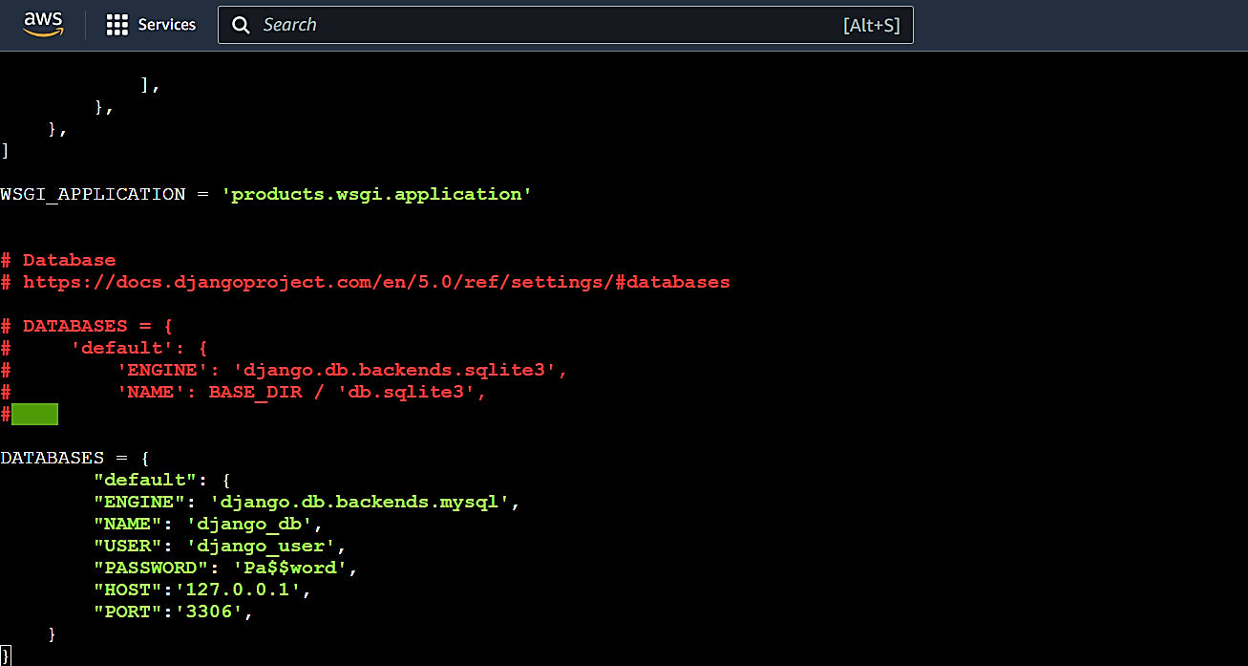

**Step 5:** import os

STATIC_URL='*/static/*'

STATIC_ROOT=os.path.join(BASE_DIR, *'static/*')

MEDIA_URL='*/media/*'

MEDIA_ROOT=os.path.join(BASE_DIR, *'media/*')

Note: Step 3-5 should edit in settings.py file.

**Step 6**: Save the file and exit.

**Step 7**: ./manage.py makemigrations

This command makes instance to migrate to db format.

**Step 8**: ./manage.py migrate

This command migrates to db format.

**Step 9:** ./manage.py createsuperuser

This command helps to create admin users.

Example:

Username (leave blank to use 'root'): **admin**

Email address: **admin@your-domain.com**

Password:

Password (again):

Superuser created successfully.

**Step 10:** ./manage.py collectstatic

For collecting all static files.

Note: Step 5-10 are optional.

**Step 11:** deactivate.

This command will exit from the env mode.

## **Configure Apache Web Server for Django**

Note: Italic words should be replaced by yourself.

**Step 1:** sudo nano /etc/apache2/sites-available/*django.conf*

**Step 2:** Enter the code as shown below.

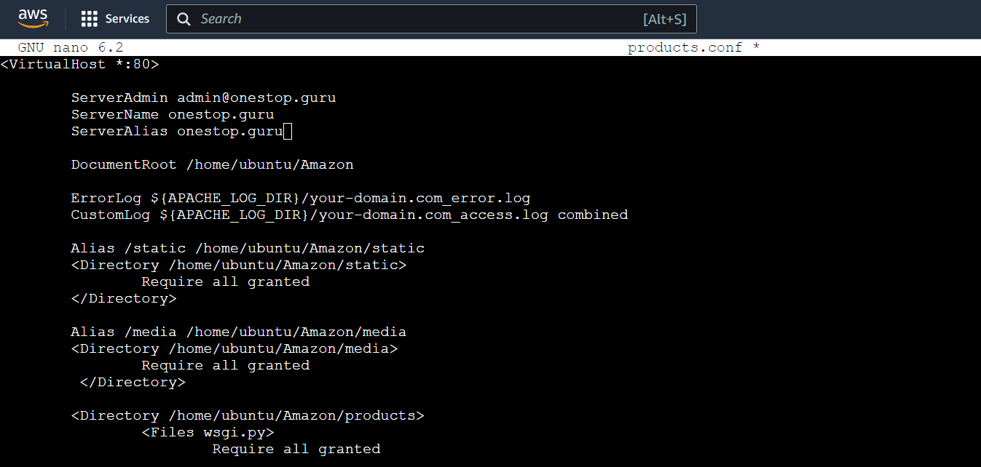

**Step 3:** sudo nano /etc/apache2/sites-available/*Django-ssl.conf*

**Step 4:** Add the code as shown below:

Alias /static */var/www/django_project/*static

<Directory */var/www/django_project/*static>

Require all granted

</Directory>

Alias /media */var/www/django_project/*media

<Directory */var/www/django_project/*media>

Require all granted

</Directory>

<Directory */var/www/django_project/django_app*>

<Files wsgi.py>

Require all granted

</Files>

</Directory>

WSGIDaemonProcess *django_app* python-path=*/var/www/django_project* python-home=*/var/www/django_project/django_env*

WSGIProcessGroup *django_app*

WSGIScriptAlias / */var/www/django_project/django_app/*wsgi.py

**Step 5:** sudo chown -R www-data:www-data */home/django_project/* OR sudo chown -R www-data:www-data /home/ubuntu/second_products/ OR sudo chmod -R 755 /home/ubuntu/second_products/(This gives permission to execute the project by apache2 server)

**Step 6:** a2ensite *django.conf* (Make sure to enter into the location of the italic file)

**Step 7:** sudo a2enmod wsgi

**Step 8:** systemctl restart apache2

**Step 9:** Enter your server ip or domain whether your website is up or not.

**Checking logs**

Most of the time, logs found in Linux are used for error troubleshooting, overall system performance and security, compliance and auditing and even analyzing logs to make determinations for the future based on past performance. Basic command for checking logs.

Cat –t /var/log/apache2/error.log

tail -n 50 /var/log/apache2/your-domain.com_error.log

tail –f /var/log/apache2/error.log

tail –f /var/log/mysql/error.log

tail -f /var/log/syslog

**Some of the issue face and solution**

Step a. If error occurs like below, the solution is given in step b.

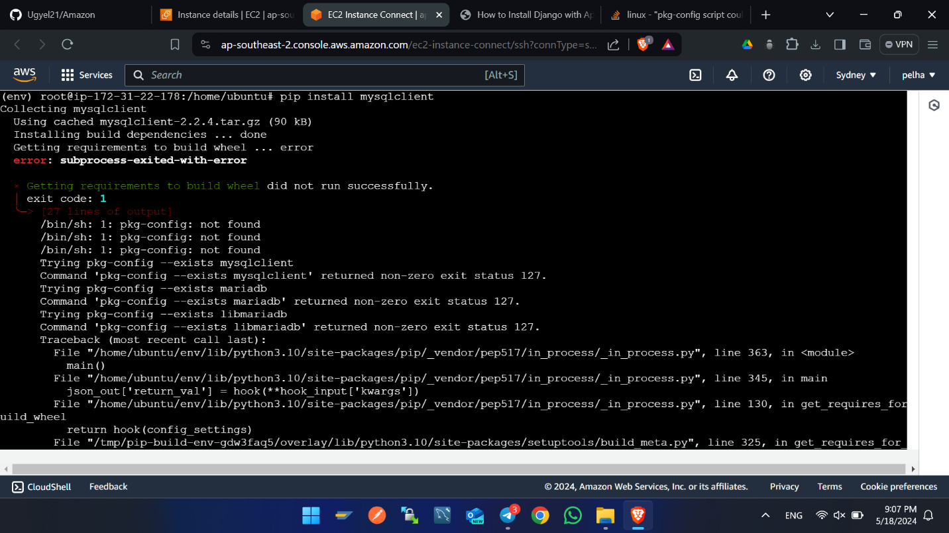

Step b. sudo apt install mysql-server libmysqlclinet-dev

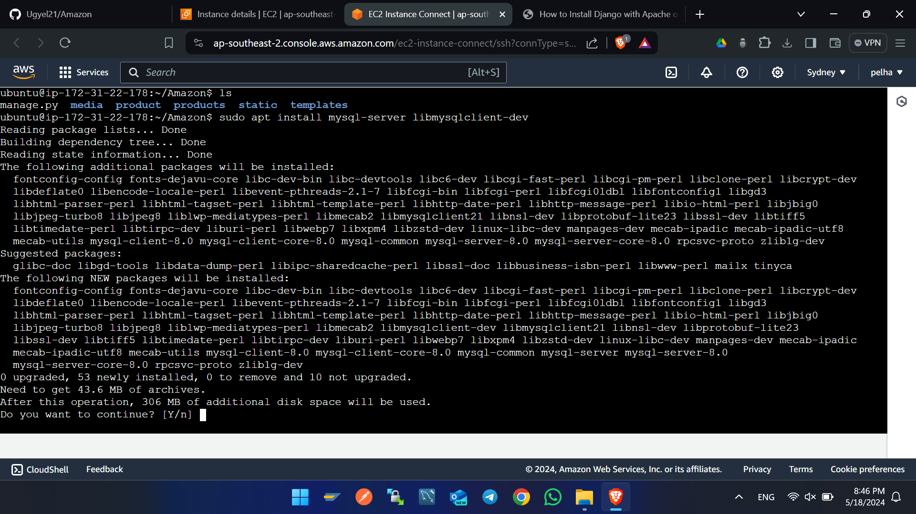

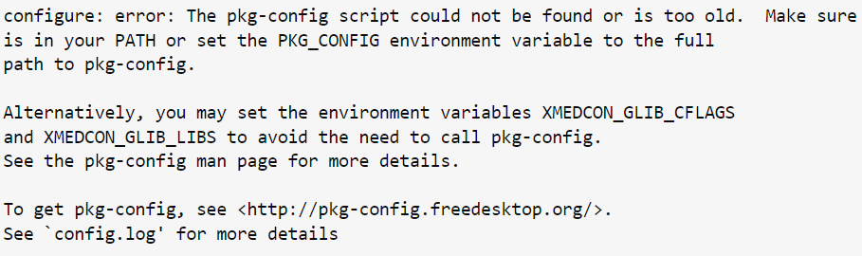Error below

**Solution for above issue:** apt-get install -y pkg-config

**Best practice for project structure**

## **Directory Hierarchy**

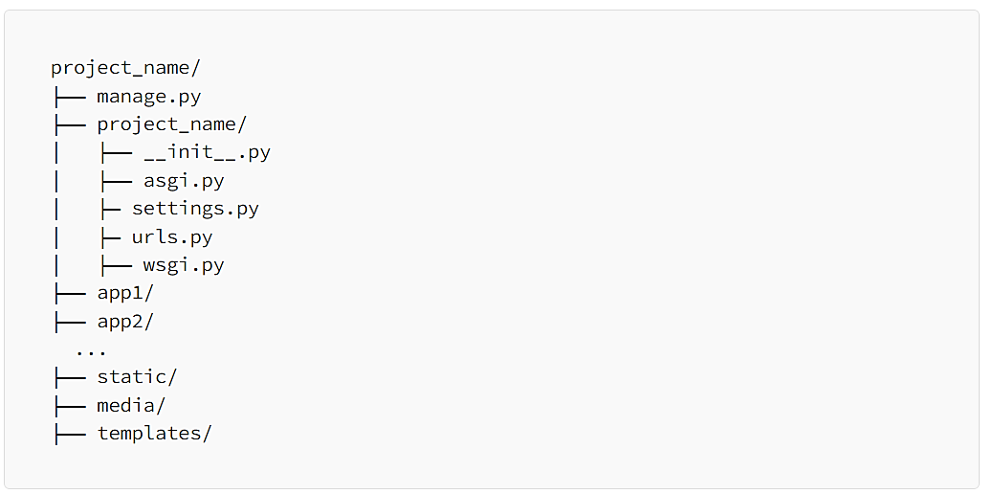

**Project_name:** The root directory of your project.

**Project_name/project_name:** This inner directory holds core project settings and configuration.

**app1, app2:** These are the individual apps you create within the project.

**static:** Houses static files like CSS, JavaScript, and images.

**media:** Stores user-uploaded files.

**templates:** Contains HTML templates.

**Naming Conventions**

Consistency in naming conventions enhances code readability. Follow these conventions:

* Apps: Use lowercase names, with underscores instead of spaces. Example: my_app.
* Modules: Use lowercase names with underscores for module files. Example: my_module.py.
* Classes: Use CamelCase for class names. Example: MyClass.
* Functions and Variables: Use lowercase with underscores for function and variable names. Example: my_function

**Modular Code Design**

Organize your codebase into modular components, making each component focused on a specific task. This makes code easier to understand, test, and maintain.

* Apps: Divide your project into multiple apps based on functionality. Each app should be self-contained, handling a specific feature.
* Views: Keep your views concise and focused on handling HTTP requests. Use class-based views for better organization.
* Models: Organize models in a way that reflects your project’s data structure. Utilize model inheritance and related fields.
* Templates: Use template inheritance to avoid code duplication. Create reusable templates and keep them organized.
* Utils: For utility functions or classes that are used across the project, create a utils module within your app.

**Settings**

Keep your project settings in the settings.py file within the inner project directory. Use environment variables for sensitive information.

**Database backup using Script and Cron job**

1. Create folder in directory /mnt
2. To go to above directory cd /mnt
3. 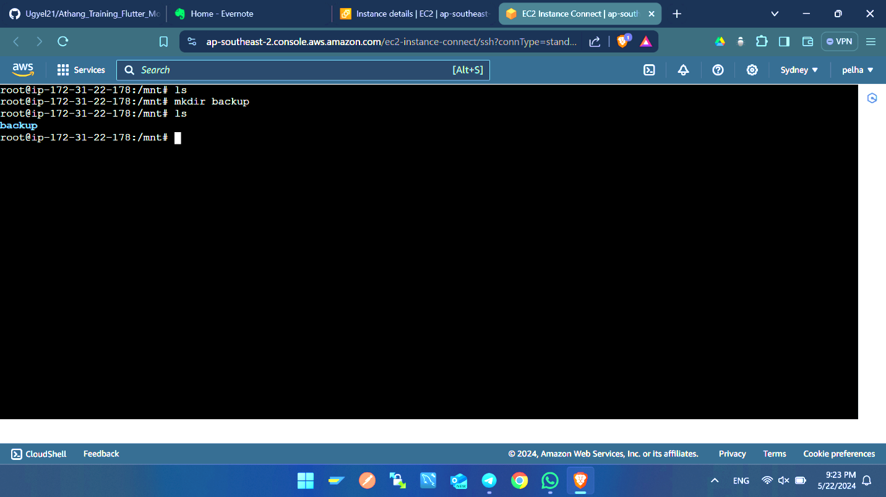The create folder called backup by using this command mkdir backup
4. Inside backup folder creates one script file called database
5. Command to create backup file -> touch database.sh
6. 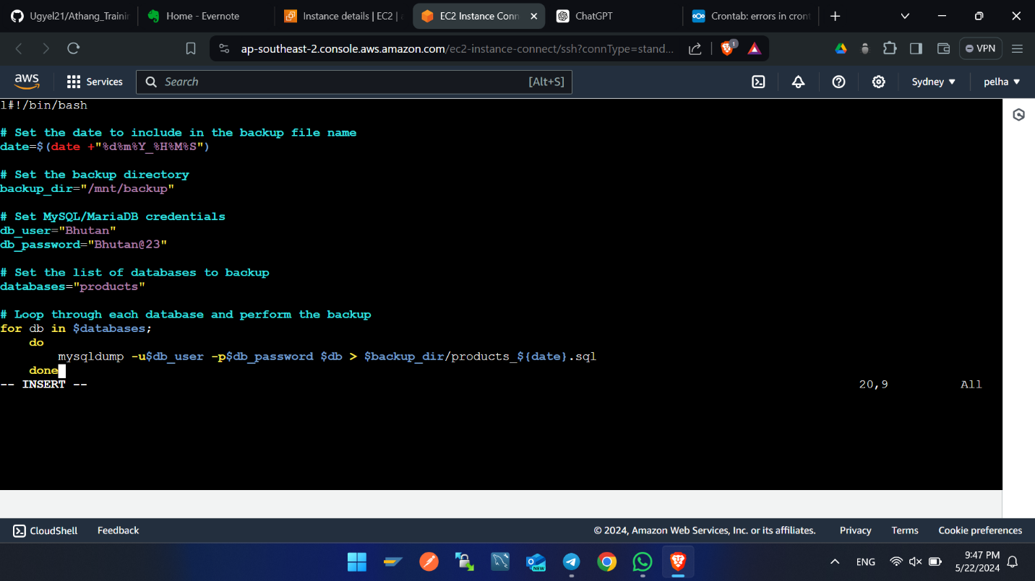Enter this line codes using by opening above database.sh file by command nano database.sh
7. Set the permission of the database.sh file by this command sudo chmod +x database.sh

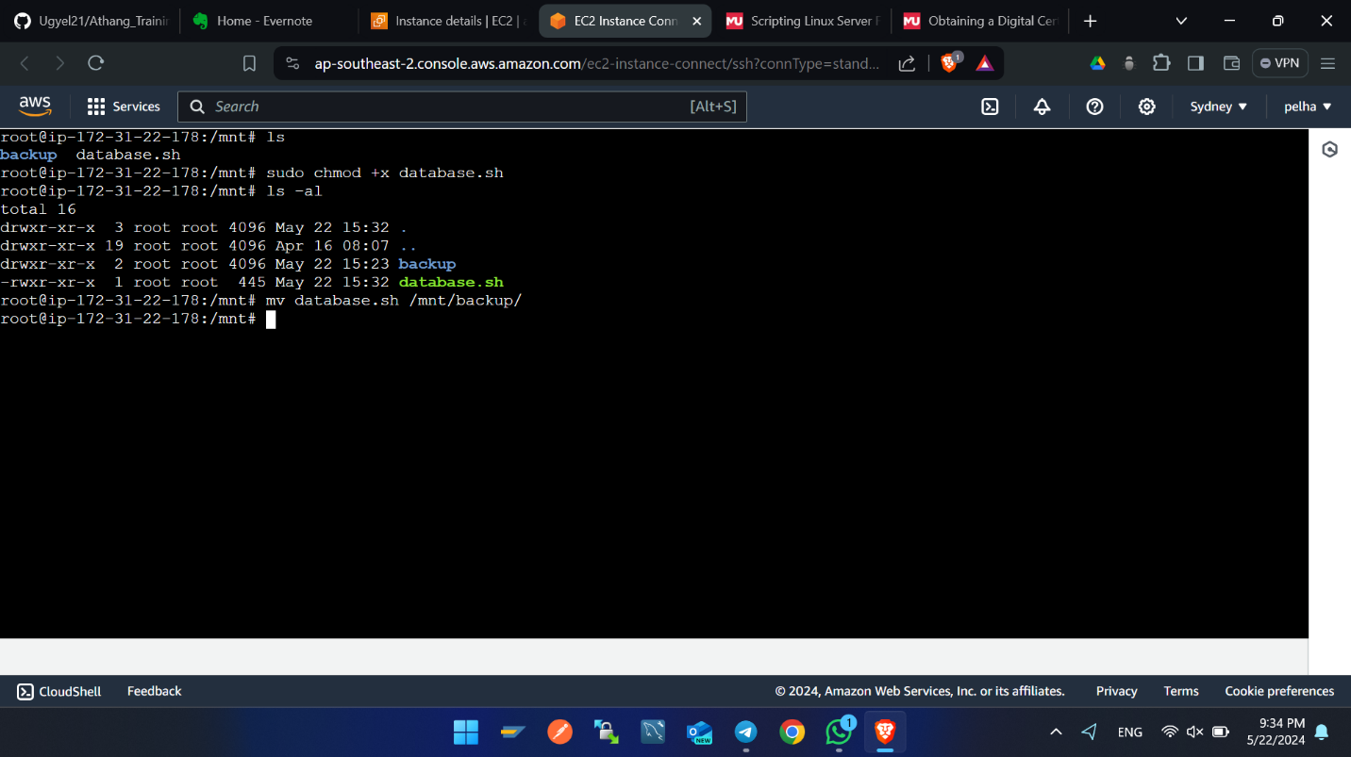

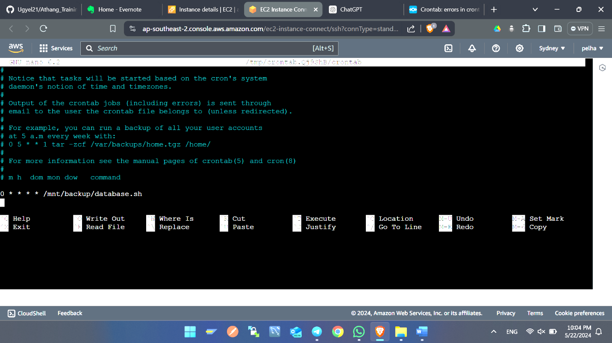8. Enter this command **crontab -e** in terminal, this command will open the editor page of crontab and one line of code in the editor at end as shown in figure below. In the below script the auto backup of db is set at every one minute.

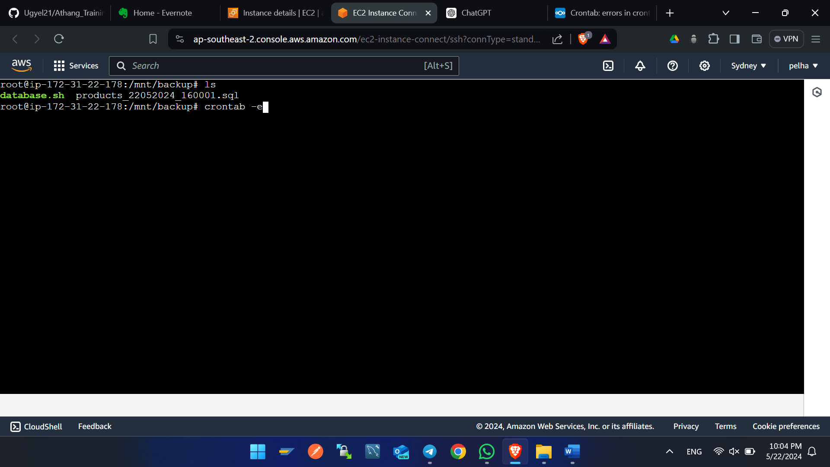9) This are the files auto backup using crontab and script file.

**Setting up the Go Daddy Domain Name with server**

A domain name is required since it acts as a convenient ‘address’ space for websites that is easier to remember than IP numbers. Instead of typing a lot on keyboard you can easily type a name for example example.com to visit the web site (onestop.guru). This aids in the usability of the internet for people and assists corporations in having polished and easily recognizable personas.

1. Visit -> <https://www.godaddy.com/en-uk>
2. Sign with credentials
3. 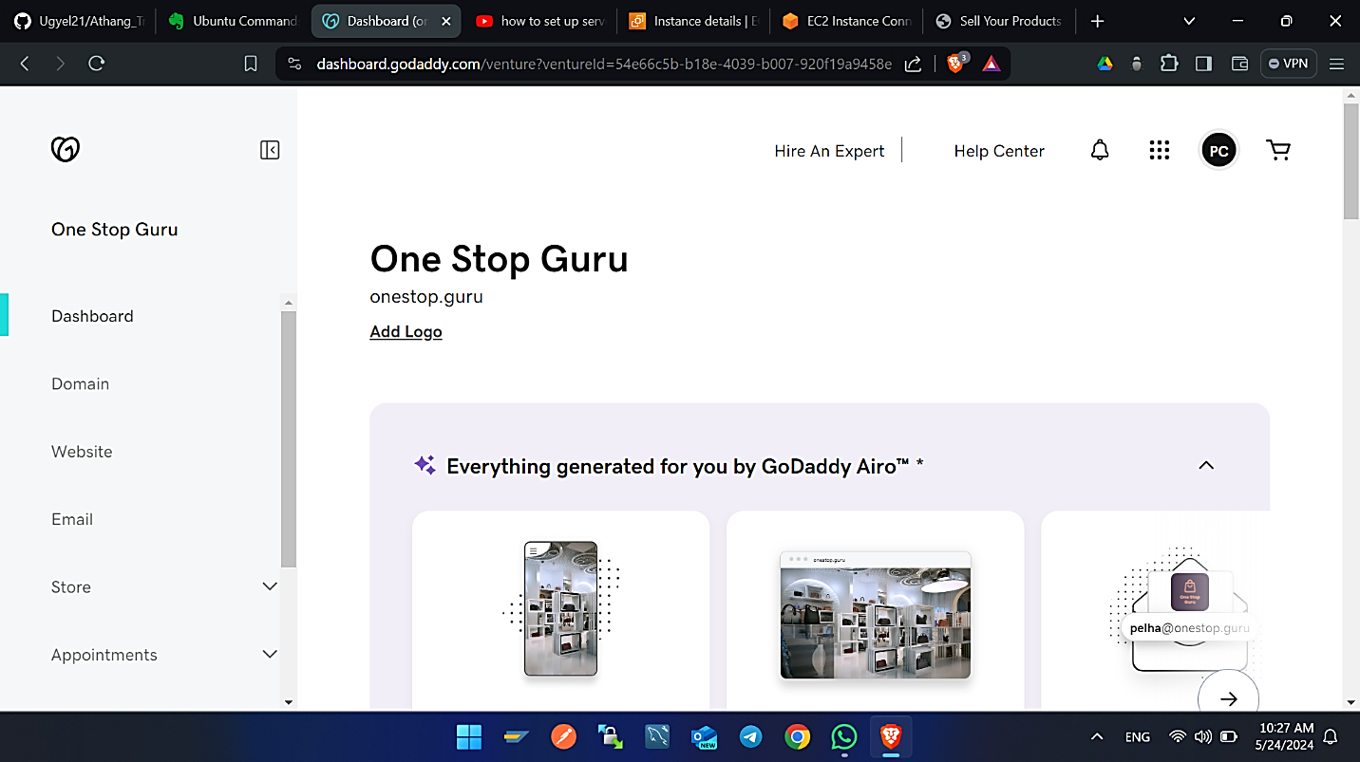In navigation bar you will find profile logo, click on that.
4. 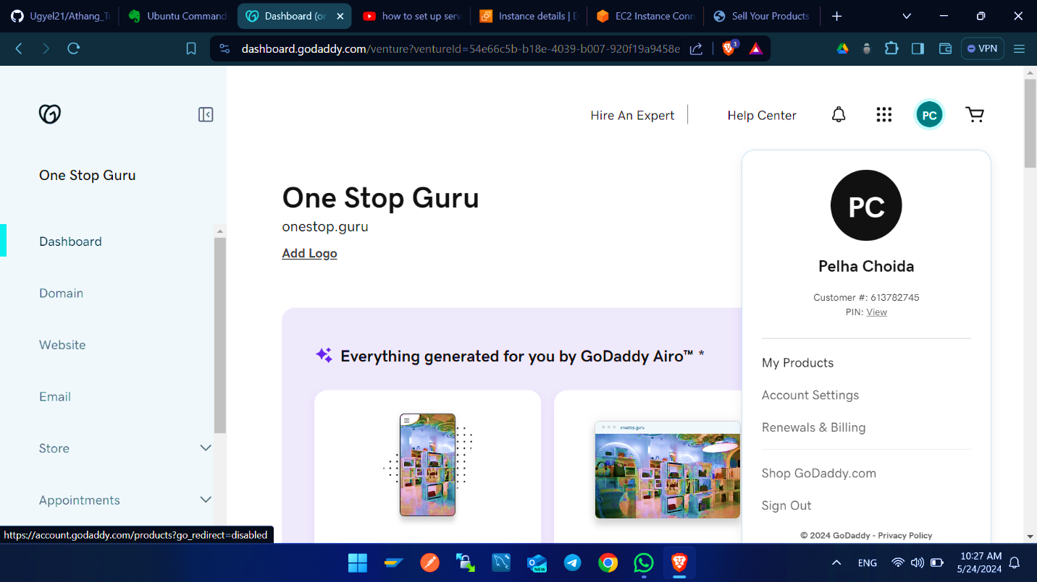Click on my products.
5. 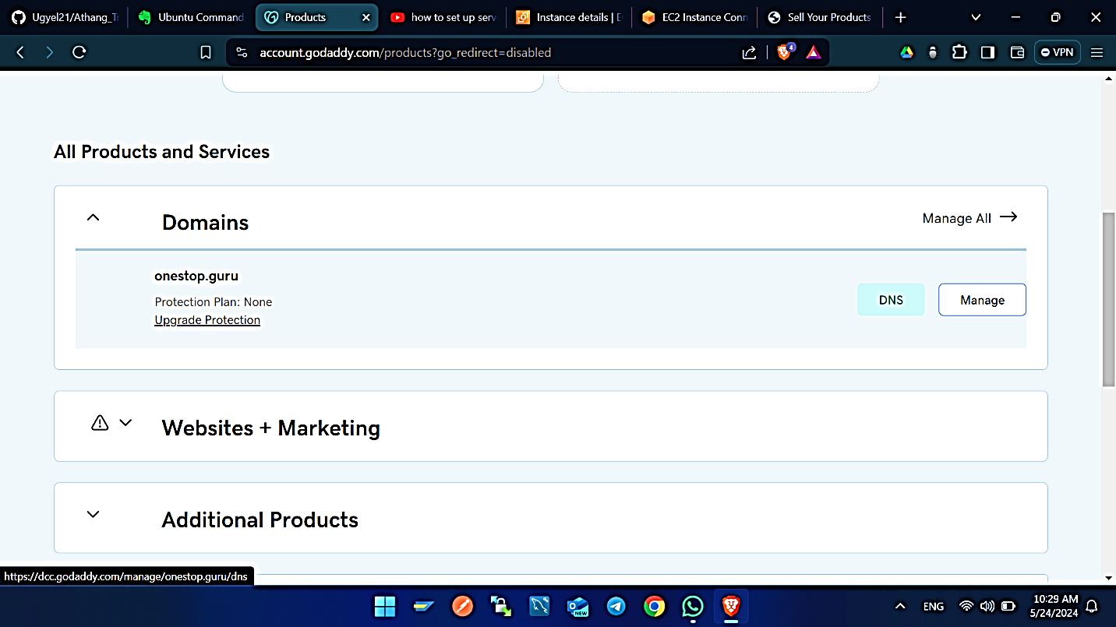Click on DNS.
6. 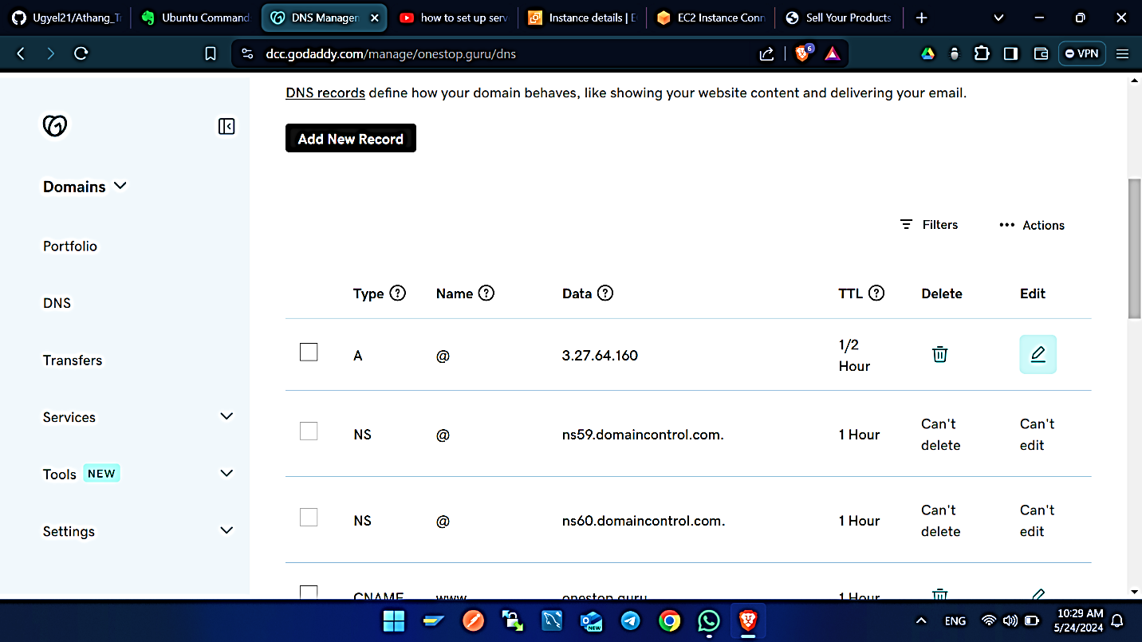Click on edit button of type A. Enter the IP of server in value filed. Then click save.
7. 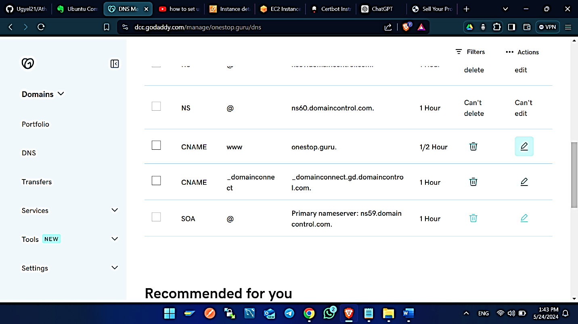Click on edit button of type CNAME and name www.
8. 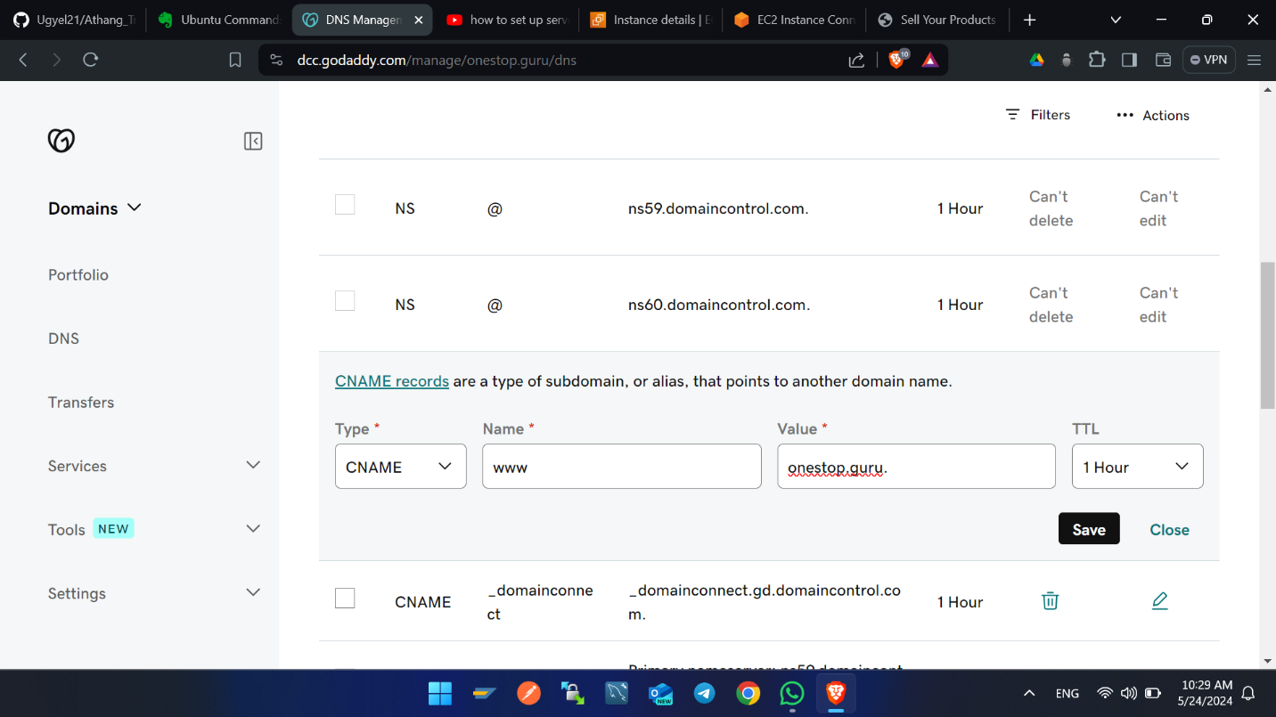Enter the value as your domain name.

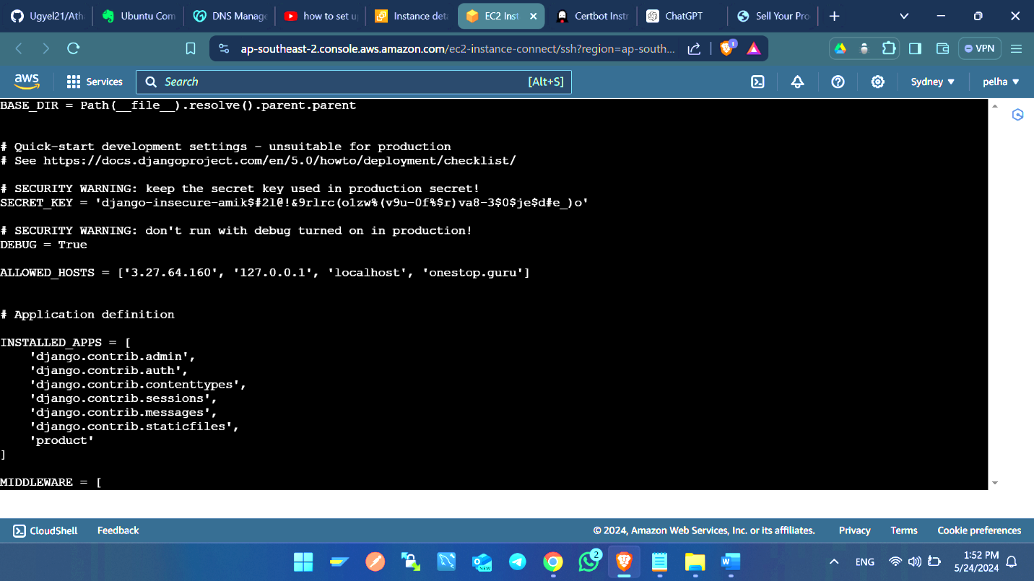After Domain Name setup, enter the domain name in the setting file of your Django project in the allowed host array.

**Enable port 443 using Cerbot**

I would like to extend reconsideration to the 443 ports as it is the most common to use the Hyper Text Transfer Protocol Secure (https:). Eventually allowing port 443 enables that browser used by the clients, establish a secure connection with the web server used by the client without possibility of compromised crucial data through eavesdropping or any other form of foul play. This is important to safeguard confidential details like login details and transactions, as well as to allow users to have confidence with the products and services as well as conform with the norms on security.

To do so follow the steps below:

Visit -> <https://certbot.eff.org/>

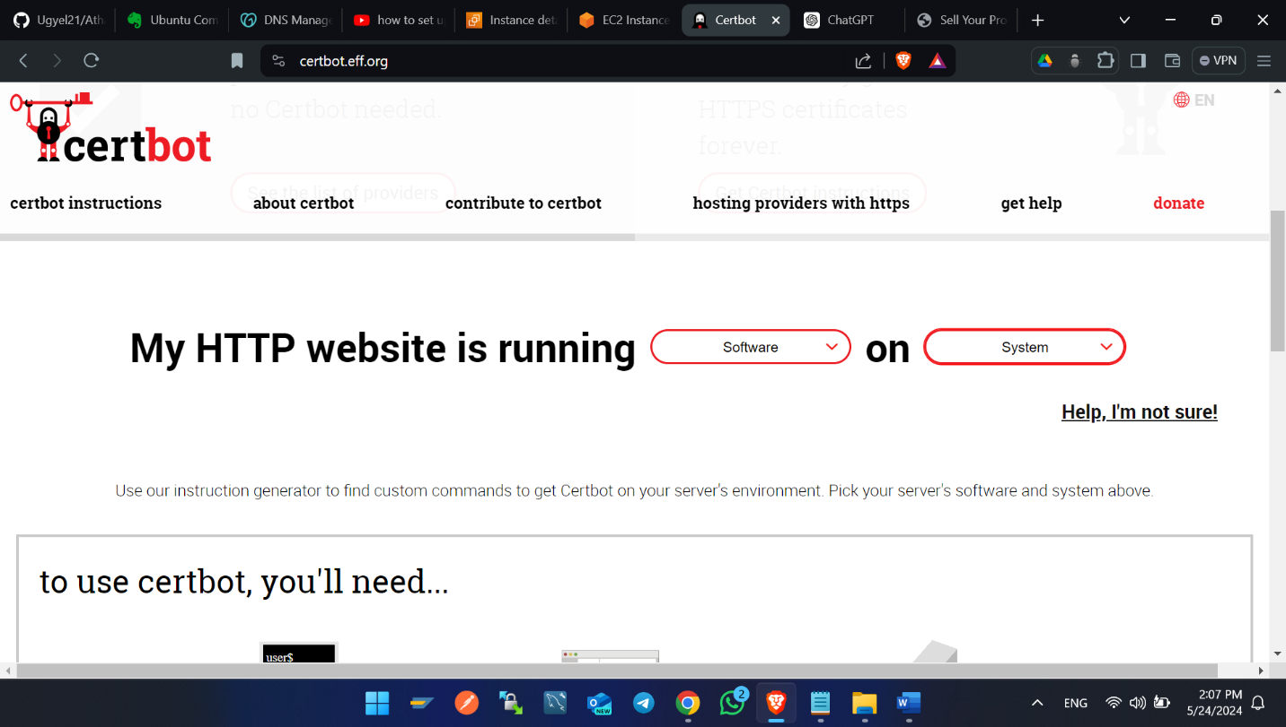Choose web server and your system. Choose Apache under software and latest version of Ubuntu listed under system.

1. 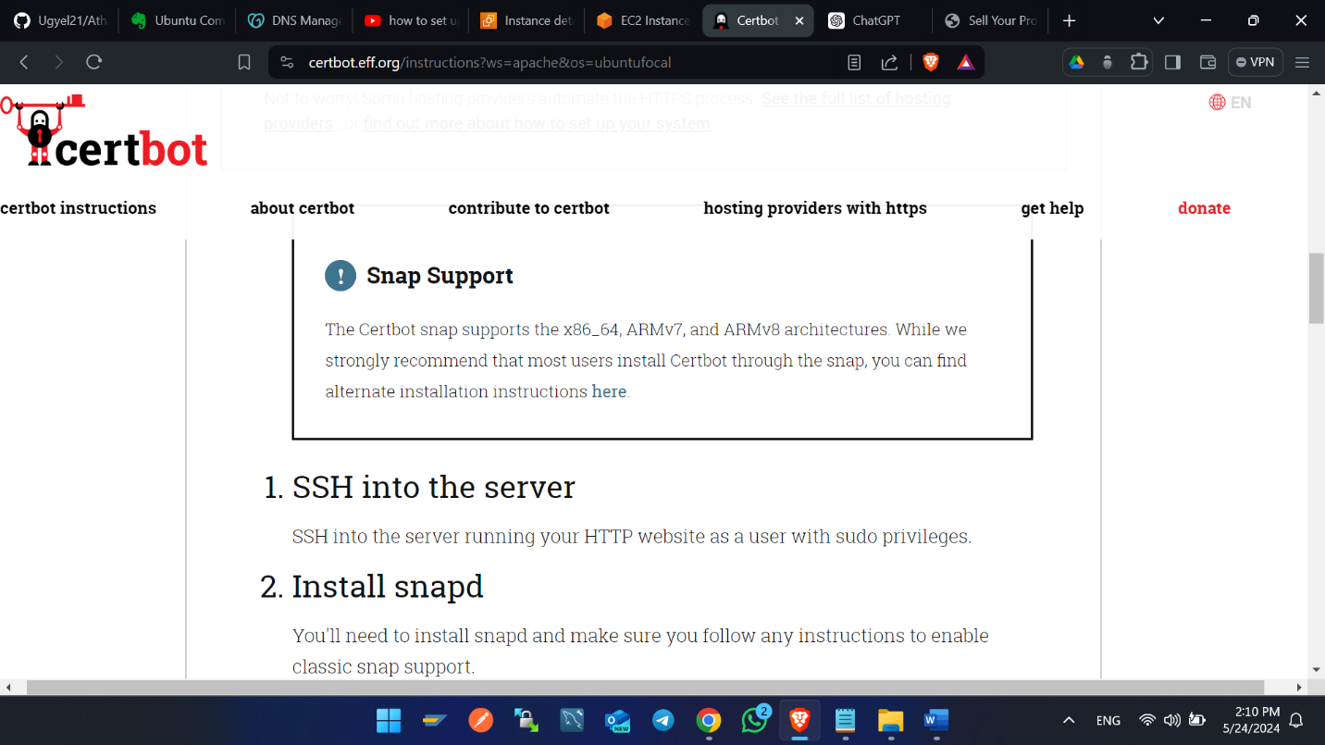After choosing and scroll down to find this type of view as shown figure below.
2. 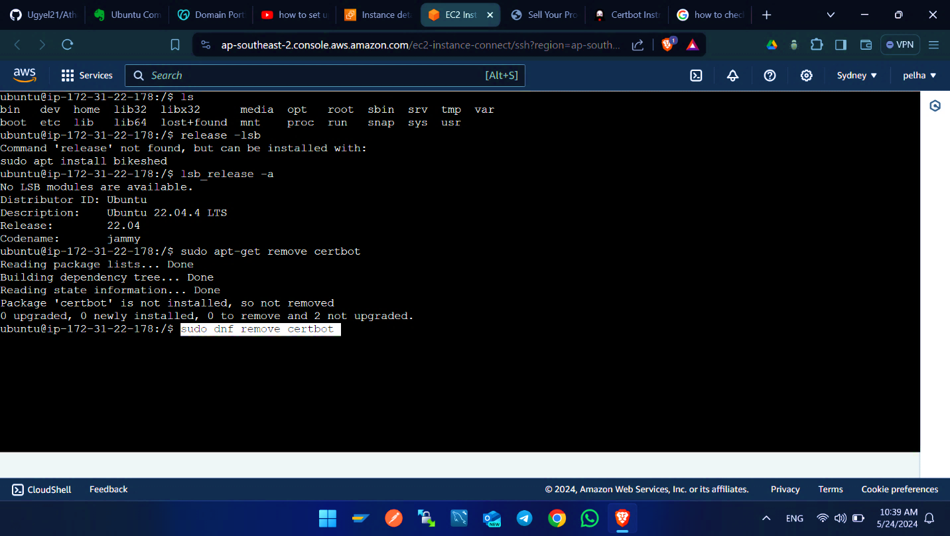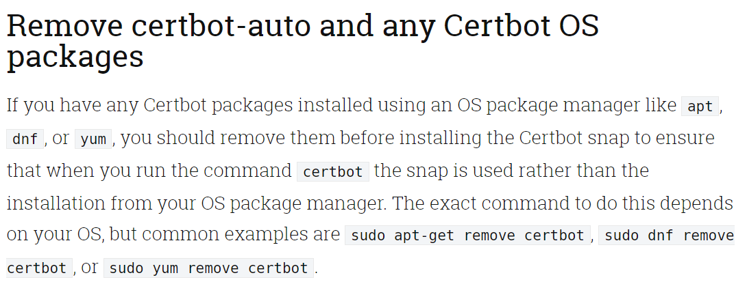Run sudo apt-get remove certbot, sudo dnf remove certbot. This command removes if cerbot is installed before.
3. 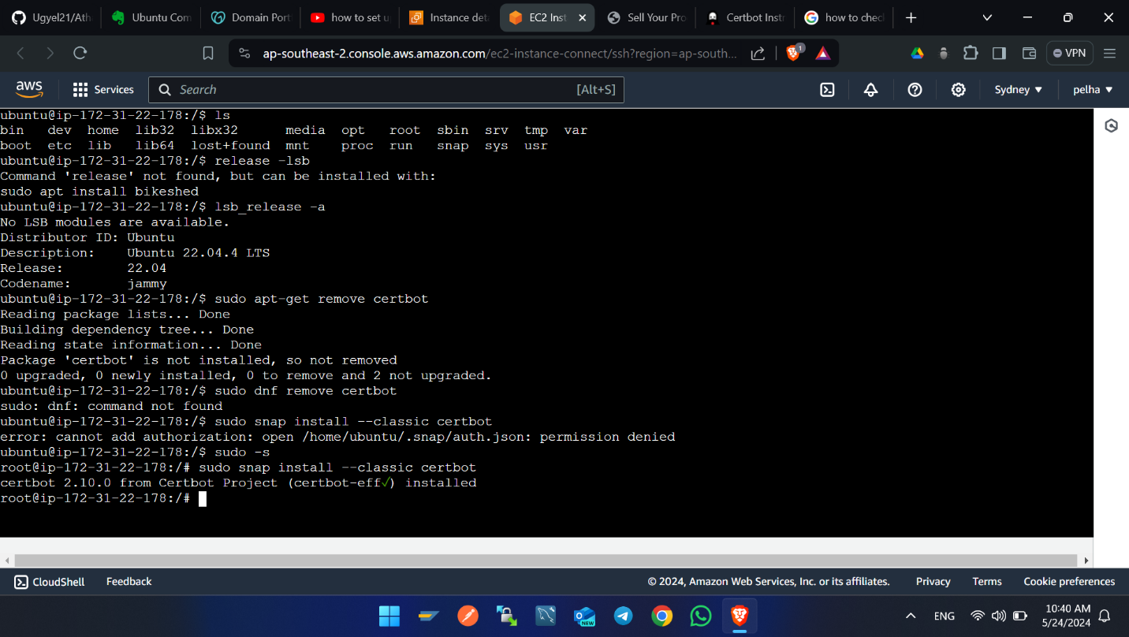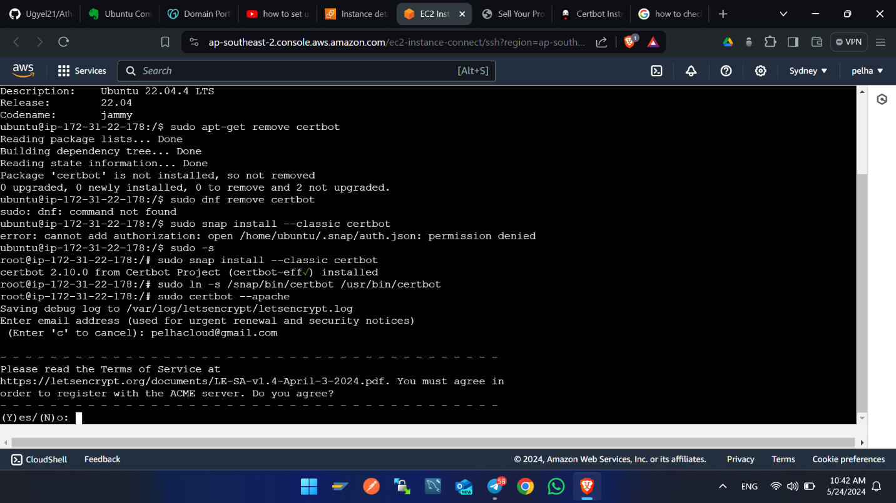Run sudo snap install --classic certbot. Enter information if it pop up and enter y to confirm and hit enter.
4. 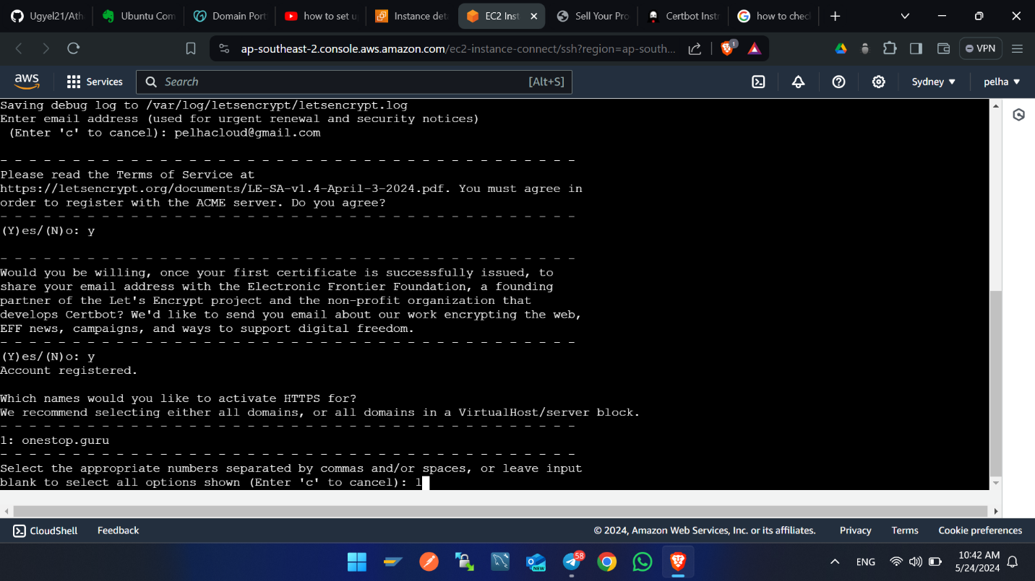Select domain name hit enter. After that the https will finally be configured.
5. Prepare the Certbot command -> sudo ln -s /snap/bin/certbot /usr/bin/certbot
6. Install certificate using this command -> sudo certbot –apache

**Auto Renew the Certificates**

contab -e

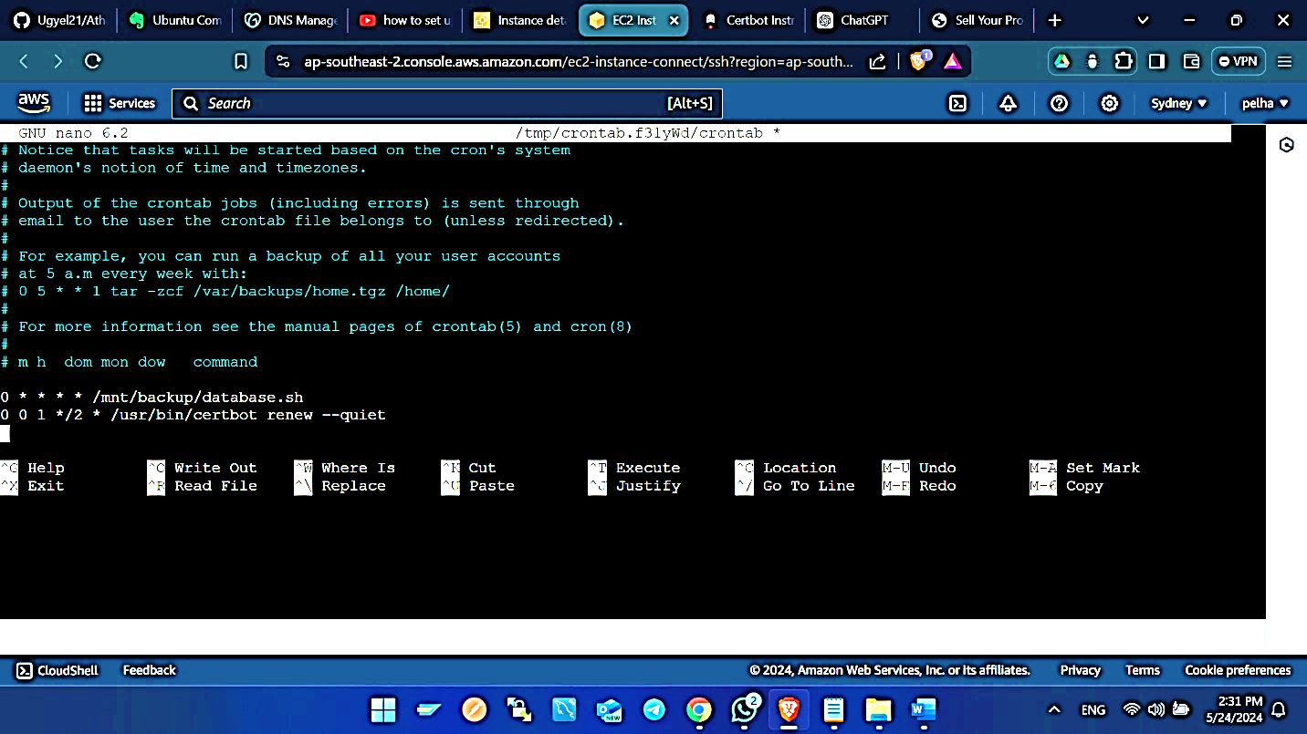Enter this line of code in editor as shown in the figure below. 0 0 1 */2 * /usr/bin/certbot renew –quiet. This line of codes renews the https certificates every 2 months.

**Some of the Linux commands used**

**cd** – Change directory. Ex> cd /home/ubunutu/second_products

**mkdir** – This creates the folder. Ex> mkdir foldername

**ls** – This list the folders in current directory. Ex> ls

**touch** – This creates the file. Ex> touch txt.py

**pwd** – This displays the path of the present working directory. Ex> pwd

**sudo -s** – Entering these commands enter into root directory. Ex sudo -s

**ls -al** – This list hidden and non-hidden files and folders. Ex ls -al

**vi** – This command mode enters editing command mode of file. Ex vi file.py

**cp** – This copies files and folders from one directory to another directory. Ex> cp filename/folder /home/ubuntu/

**mv** – This moves or renames the file. Ex mv filename filename1, mv file /home/ubuntu.

**rm** – This removes the files and folders. Ex> rm file/folder

**rm -f** – This removes the parent folder plus inside files and folders forcefully. Ex> rm -f folder.

**datetime** – Displays date and time of server. Ex> datetime

**chown -R** – It is used to change the ownership of files and directories. Ex> sudo chown -R www-data:www-data /home/ubuntu/second_products

**chomd** – These changes the permission of file and folder. Ex> chmod 755 filename

7 (4 + 2 + 1): Read, write, and execute

6 (4 + 2): Read and write

5 (4 + 1): Read and execute

**Scripts**

In the case of Linux specifically, scripting implies creating programs, or scripts, which are plain text files containing a list of commands to be executed by the shell. The forms of scripts are to automate the work, manage the system, and perform the tasks that are repetitive in nature.

Copying files and folders from one directory to another directory

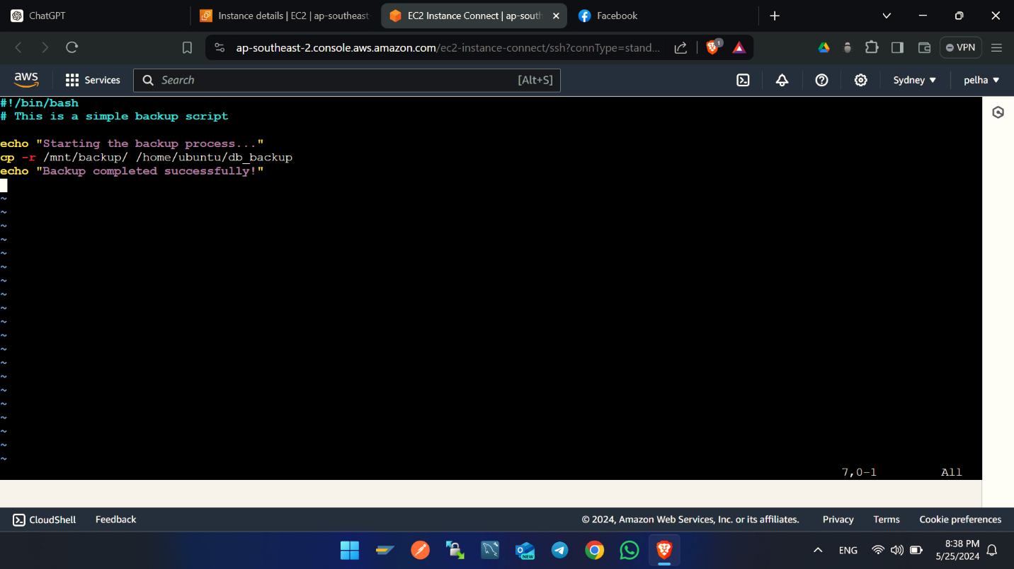vi backup_db.sh

chomd +x backup_db.sh -> This makes files executable.

./backup_db.sh -> this executes the commands.

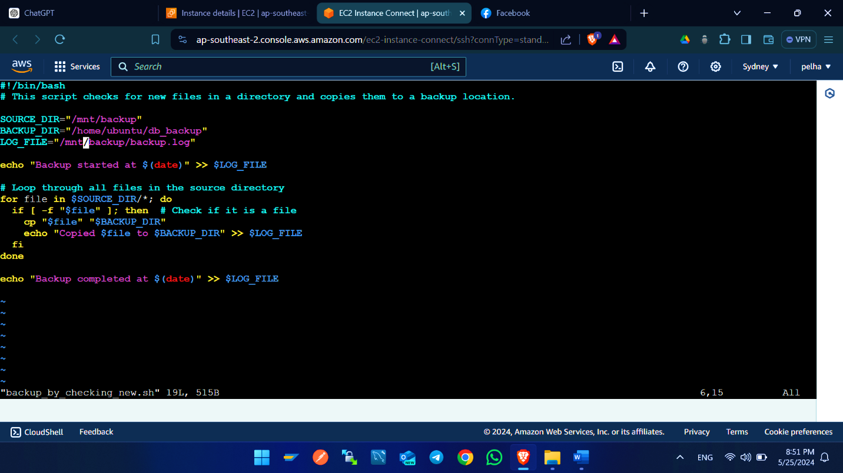Copying files by checking new files

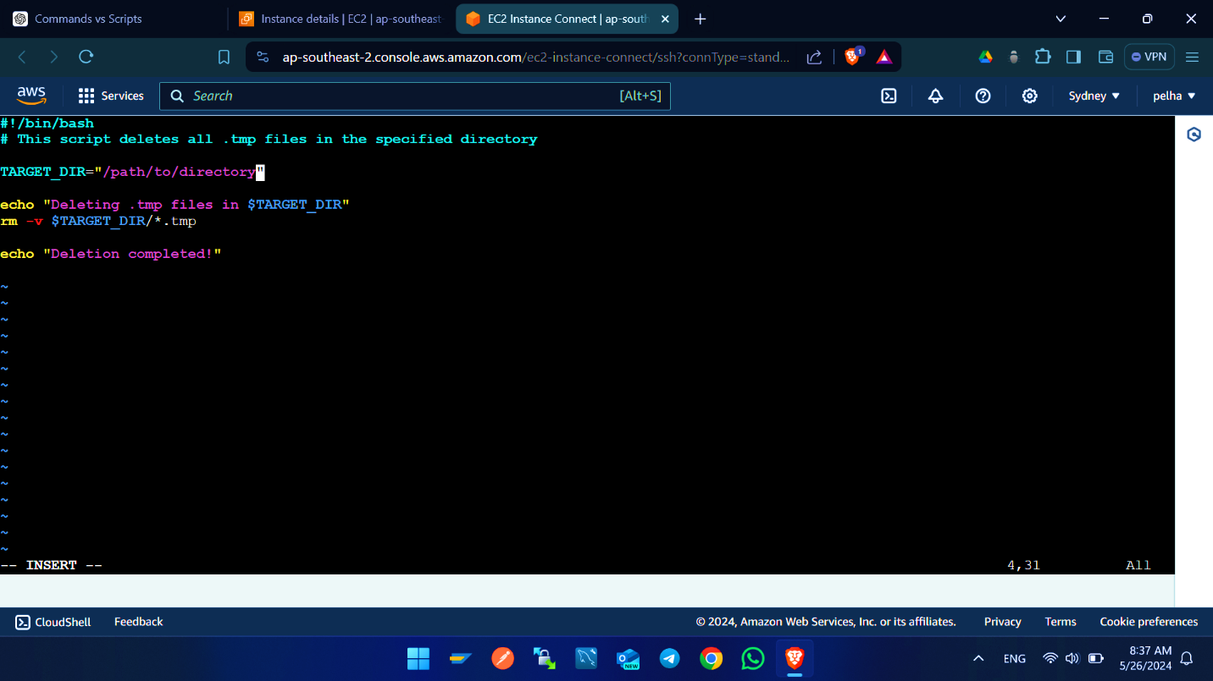This script deletes all .tmp files in the specified directory.

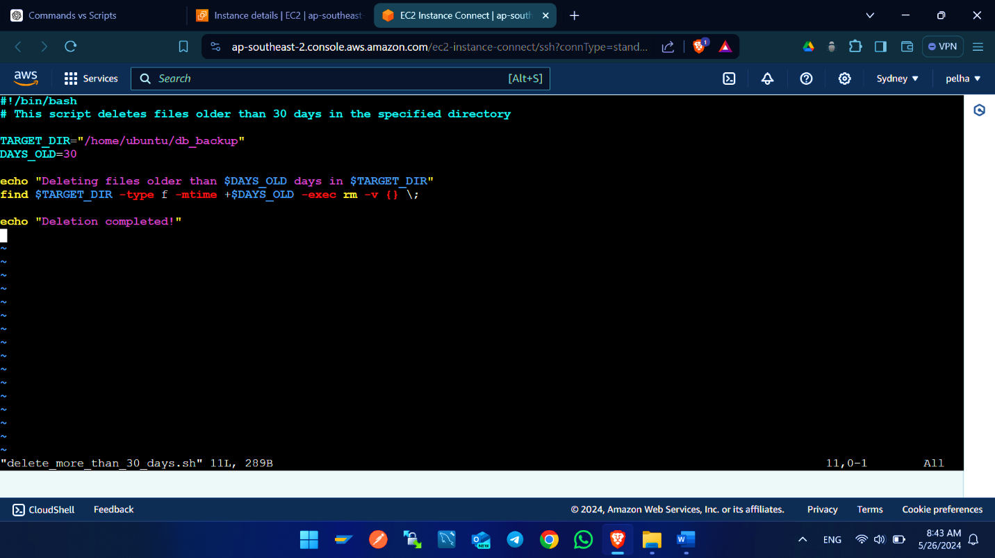This script deletes files older than 30 days in the specified directory.

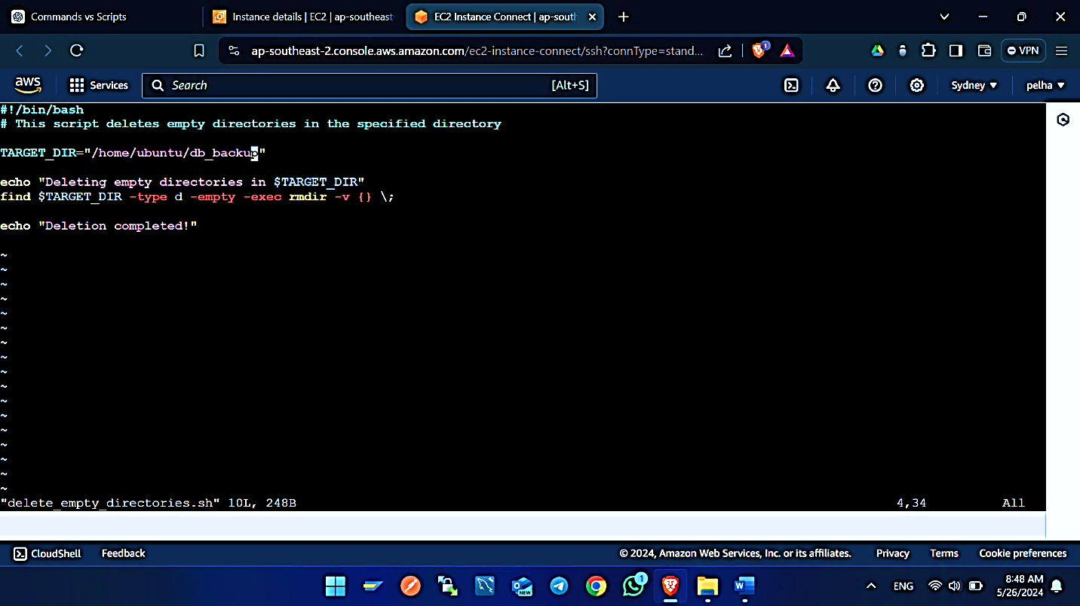This script deletes empty directories in a specified directory.

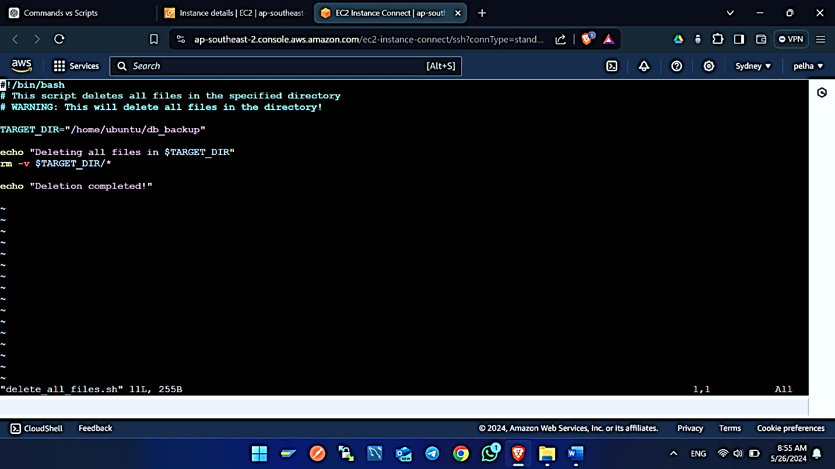This script deletes all files in a specified directory.

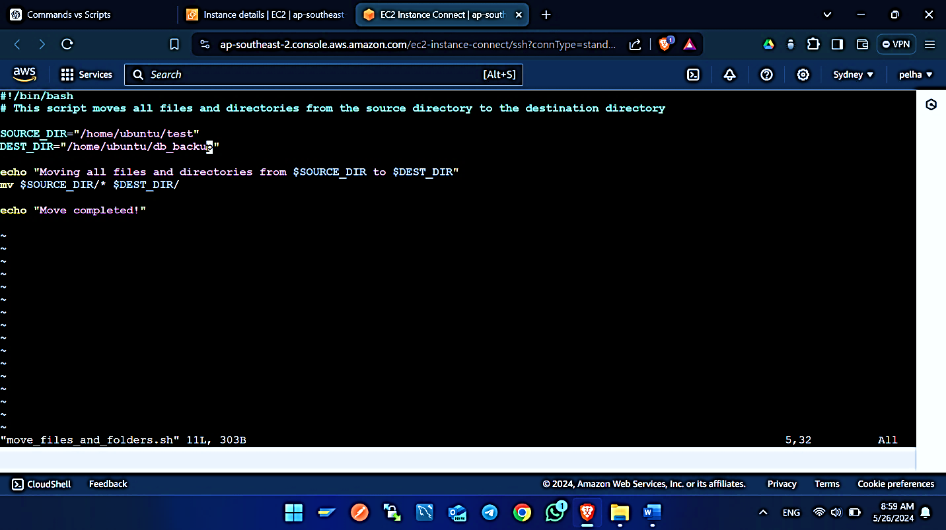This script moves all files and directories from a source directory to a destination directory.

**References**

1. awstip.com. (2023). *A Step-by-Step Guide to Creating an Amazon EC2 Instance*.
2. Simic, D. ed., (2024). *Buying Domain Name from GoDaddy: Step-by-Step Guide.*
3. Anon, (2016). *How To Serve Django Applications with Apache and mod_wsgi on Ubuntu 16.04.*
4. . certbot. (n.d.). *a project of the Electronic Frontier Foundation.*
5. https://stackoverflow.com/. (n.d.). *Share Your Experience: Take the 2024 Developer Survey.*
6. https://www.youtube.com/@ServerOKin. (2021). *How to Change Nameservers in GoDaddy.*
7. Perez, J. (2007). *Django Project Structure*: A. <https://medium.com/django-unleashed/django-project-structure-a-comprehensive-guide-4b2ddbf2b6b8>.